CLOUD COMPUTING LAB | CSE12045

EXPERIMENT 5
Implementation of Various Scheduling Mechanisms Using an Open-Source Cloud Simulator

1 Update Ubuntu

sudo apt update
Why: Refreshes Ubuntu’s package index so the system can identify available package versions. sudo sudo apt upgrade -y
Why: Installs available updates for already-installed software. The -y flag automatically confirms the operation.
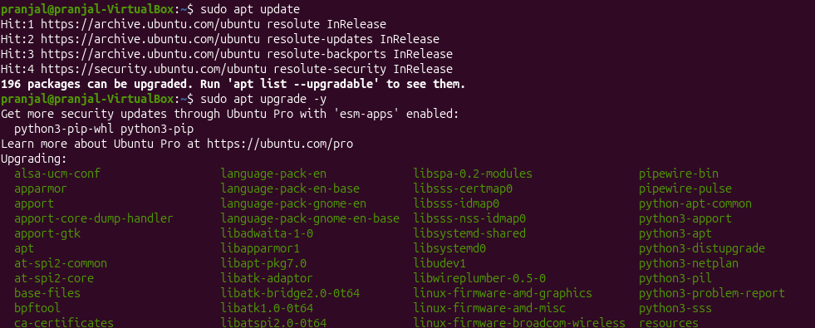

2 Install Java, Maven and Git sudo apt install openjdk-17-jdk maven git -y
Why: Installs the Java compiler/runtime, Maven build tool and Git version-control utility. java -version
Why: Checks the installed Java runtime version. javac -version
Why: Checks that the Java compiler is available.

mvn -version
Why: Confirms Maven installation and displays the Java version Maven uses. git --version
Why: Confirms Git installation.
Expected check: Java and javac should report version 17.x. Maven should display a version and show that it is using Java 17. Resolve any Java-version mismatch before proceeding.
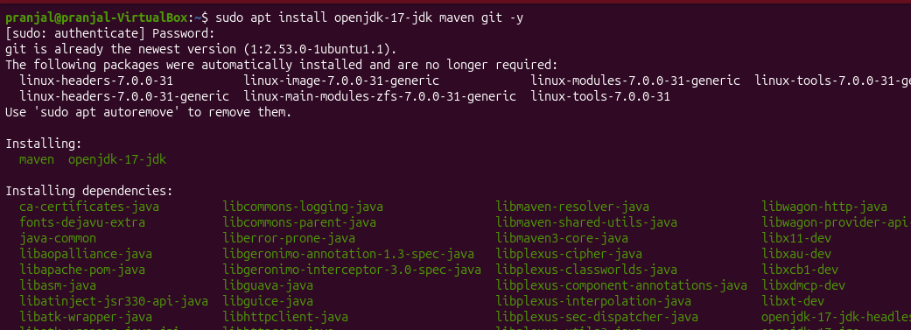
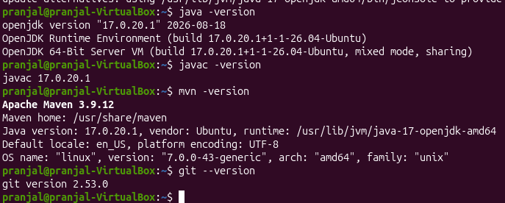

3. Create the CloudSim Plus Maven project
3.1 Create folders mkdir -p ~/CloudSchedulingLab/src/main/java/lab
Why: Creates the project directory and standard Maven Java source directory. -p creates missing parent directories too.
cd ~/CloudSchedulingLab
Why: Changes the terminal’s current directory to the project root.
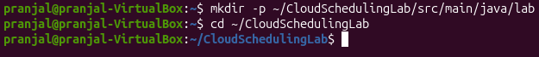

3.2 Create pom.xml nano pom.xml
Why: Opens the nano text editor to create the Maven configuration file.
Enter the following content exactly:
<project xmlns="http://maven.apache.org/POM/4.0.0" xmlns:xsi="http://www.w3.org/2001/XMLSchema-instance" xsi:schemaLocation="http://maven.apache.org/POM/4.0.0 https://maven.apache.org/xsd/maven-4.0.0.xsd">
<modelVersion>4.0.0</modelVersion>
<groupId>lab</groupId>
<artifactId>cloud-scheduling-lab</artifactId>
<version>1.0-SNAPSHOT</version>
<properties>
<maven.compiler.release>17</maven.compiler.release>
<project.build.sourceEncoding>UTF-8</project.build.sourceEncoding>
</properties>
<dependencies>
<dependency>
<groupId>org.cloudsimplus</groupId>
<artifactId>cloudsimplus</artifactId>
<version>8.5.5</version>
</dependency>
</dependencies>
</project>
Save in nano: Ctrl+O, press Enter, then Ctrl+X.
Why this file is required: It defines the Maven project, sets Java 17 as the target and declares CloudSim Plus as a dependency. Maven downloads the required library files automatically.

3.3 Resolve dependencies mvn dependency:resolve
Why: Downloads the declared CloudSim Plus library and supporting dependencies into Maven’s local repository. mvn clean
Why: Removes old build output (the target directory), ensuring the next build starts cleanly.
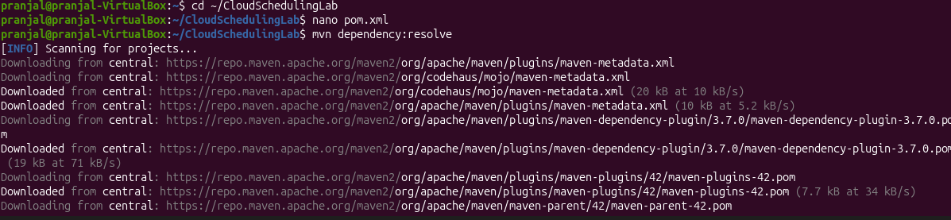
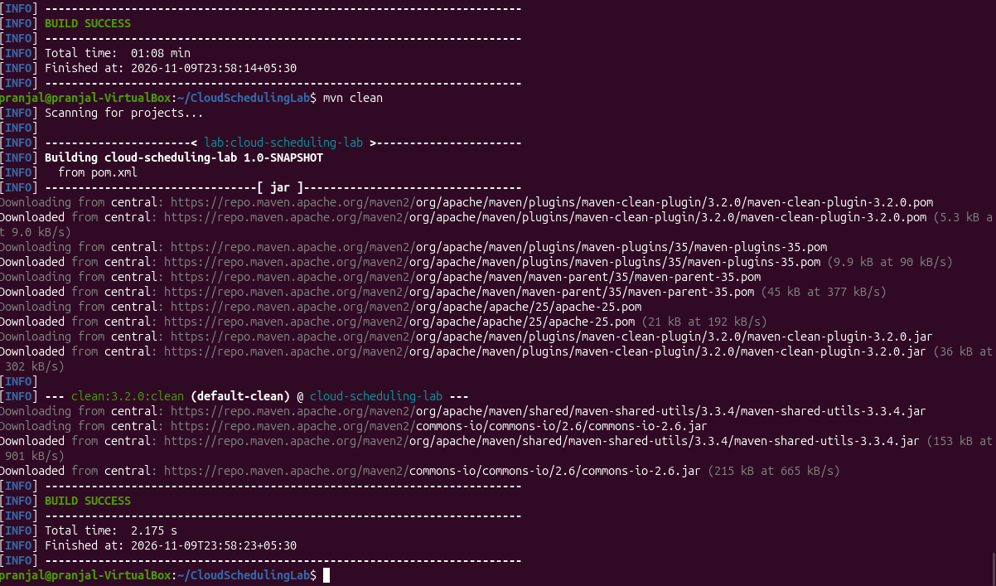

4. Implement the experiment

nano src/main/java/lab/SchedulingExperiment.java
Why: Creates the Java source file containing the simulation setup, scheduler configurations and output code.
Copy the complete Java program below. Preserve the package declaration and all class/method names.
package lab;
import java.util.ArrayList;
import java.util.List;
import java.util.function.Supplier;
import org.cloudsimplus.core.CloudSimPlus;
import org.cloudsimplus.datacenters.Datacenter;
import org.cloudsimplus.datacenters.DatacenterSimple;
import org.cloudsimplus.brokers.DatacenterBroker;
import org.cloudsimplus.brokers.DatacenterBrokerSimple;
import org.cloudsimplus.cloudlets.Cloudlet;
import org.cloudsimplus.cloudlets.CloudletSimple;
import org.cloudsimplus.hosts.Host;
import org.cloudsimplus.hosts.HostSimple;
import org.cloudsimplus.resources.Pe;
import org.cloudsimplus.resources.PeSimple;
import org.cloudsimplus.schedulers.cloudlet.CloudletScheduler;
import org.cloudsimplus.schedulers.cloudlet.CloudletSchedulerSpaceShared;
import org.cloudsimplus.schedulers.cloudlet.CloudletSchedulerTimeShared;
import org.cloudsimplus.schedulers.vm.VmScheduler;
import org.cloudsimplus.schedulers.vm.VmSchedulerSpaceShared;
import org.cloudsimplus.schedulers.vm.VmSchedulerTimeShared;
import org.cloudsimplus.utilizationmodels.UtilizationModel;
import org.cloudsimplus.utilizationmodels.UtilizationModelFull;
import org.cloudsimplus.vms.Vm;
import org.cloudsimplus.vms.VmSimple;
import org.cloudsimplus.allocationpolicies.VmAllocationPolicySimple;

public class SchedulingExperiment {
private static final int HOST_PES = 4;
private static final int VM_COUNT = 2;
private static final int CLOUDLET_COUNT = 4;
private static final long MIPS = 1000;
private static final long CLOUDLET_LENGTH = 20000;

public static void main(String[] args) {
runScenario(
"A: VM SpaceShared + Cloudlet SpaceShared",
new VmSchedulerSpaceShared(),
CloudletSchedulerSpaceShared::new
);

runScenario(
"B: VM SpaceShared + Cloudlet TimeShared",
new VmSchedulerSpaceShared(),
CloudletSchedulerTimeShared::new
);

runScenario(
"C: VM TimeShared + Cloudlet SpaceShared",
new VmSchedulerTimeShared(),
CloudletSchedulerSpaceShared::new
);

runScenario(
"D: VM TimeShared + Cloudlet TimeShared",
new VmSchedulerTimeShared(),
CloudletSchedulerTimeShared::new
);
}

private static void runScenario(
String title,
VmScheduler vmScheduler,
Supplier<CloudletScheduler> cloudletSchedulerFactory) {

System.out.println("\n==================================================");
System.out.println(title);
System.out.println("==================================================");

CloudSimPlus simulation = new CloudSimPlus();
createDatacenter(simulation, vmScheduler);
DatacenterBroker broker = new DatacenterBrokerSimple(simulation);
List<Vm> vmList = createVms(cloudletSchedulerFactory);
List<Cloudlet> cloudletList = createCloudlets();
broker.submitVmList(vmList);
broker.submitCloudletList(cloudletList);
simulation.start();
List<Cloudlet> finished = broker.getCloudletFinishedList();
System.out.printf(
"%-10s %-10s %-12s %-12s %-12s%n",
"Cloudlet", "VM", "Status", "Start", "Finish"
);

for (Cloudlet cloudlet : finished) {
System.out.printf(
"%-10d %-10d %-12s %-12.2f %-12.2f%n",
cloudlet.getId(),
cloudlet.getVm().getId(),
cloudlet.getStatus(),
cloudlet.getStartTime(),
cloudlet.getFinishTime()
);
}

System.out.println(
"Completed Cloudlets: " + finished.size()
+ " / " + CLOUDLET_COUNT
);
}

private static Datacenter createDatacenter(
CloudSimPlus simulation,
VmScheduler vmScheduler) {
List<Pe> peList = new ArrayList<>();
for (int i = 0; i < HOST_PES; i++) {
peList.add(new PeSimple(MIPS));
}

Host host = new HostSimple(
8192,
100000,
1000000,
peList
);

host.setVmScheduler(vmScheduler);

List<Host> hostList = new ArrayList<>();
hostList.add(host);

return new DatacenterSimple(
simulation,
hostList,
new VmAllocationPolicySimple()
);
}

private static List<Vm> createVms(
Supplier<CloudletScheduler> cloudletSchedulerFactory) {

List<Vm> vmList = new ArrayList<>();

for (int i = 0; i < VM_COUNT; i++) {

Vm vm = new VmSimple(i, MIPS, 2);

vm.setRam(2048)
.setBw(10000)
.setSize(10000);

vm.setCloudletScheduler(cloudletSchedulerFactory.get());

vmList.add(vm);
}

return vmList;
}

private static List<Cloudlet> createCloudlets() {

List<Cloudlet> cloudletList = new ArrayList<>();

UtilizationModel utilization = new UtilizationModelFull();

for (int i = 0; i < CLOUDLET_COUNT; i++) {

Cloudlet cloudlet = new CloudletSimple(
CLOUDLET_LENGTH,
1,
utilization
);

cloudlet.setSizes(300);

cloudletList.add(cloudlet);
}

return cloudletList;
}
}
Save: Ctrl+O → Enter → Ctrl+X.

5. Compile and execute
5.1 Compile mvn clean compile
Why: Compiles the Java source code and reports syntax or API errors before running the simulation.

5.2 Run mvn exec:java -Dexec.mainClass="lab.SchedulingExperiment" -Dexec.classpathScope=compile
Why: Executes the main() method with Maven and the project dependency classpath.
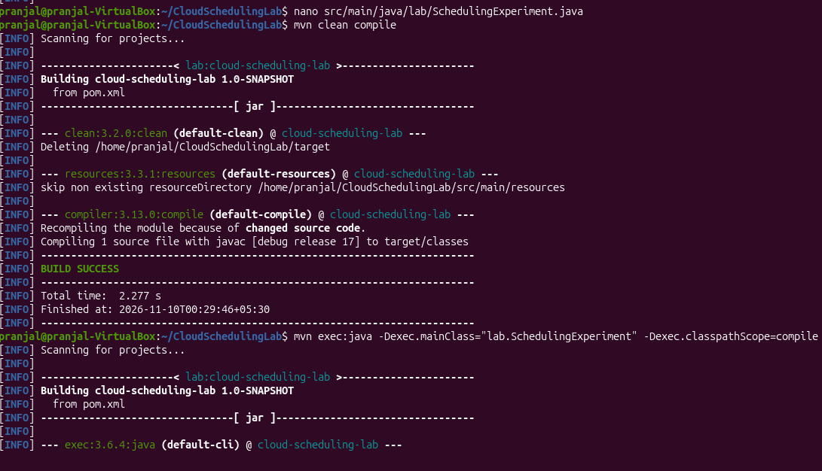
If the exec plugin prefix is not resolved, run the fully qualified plugin command:

mvn org.codehaus.mojo:exec-maven-plugin:3.5.0:java -Dexec.mainClass="lab.SchedulingExperiment" -Dexec.classpathScope=compile
Why: Invokes a specific Maven Exec plugin version directly.


